**Supplemental Materials**

**Ventromedial prefrontal cortex contributes to performance success by controlling reward-driven arousal representation in amygdala**

Noriya Watanabe* 1,2,3,4, Jamil P Bhanji1, Hiroki C Tanabe3, Mauricio R Delgado* 1

1. Department of Psychology, Rutgers University, 101 Warren Street, Newark, NJ 07102, USA

2.Research Center for Brain Communication, Kochi University of Technology, Kochi 782-8502, Japan

3. Graduate School of Informatics, Nagoya University, Nagoya 464-8601, Japan

4. Center for Information and Neural Networks, National Institute of Information and Communications Technology, Osaka 565-0871, Japan

*Correspondence: noriyawtnb@gmail.com, delgado@psychology.rutgers.edu

Page 2: Supplemental Figure 1

Beta estimates and those correlations across VMPFC, amygdala, and caudate nucleus.

Page 3: Supplemental Figure 2

Anatomical connections among reported regions in the current results.

Page 4: Supplemental Figure 3

Result of dynamic causal modeling with 8 seed regions.

Page 5-6: Supplemental Methods

Additional DCM with eight seed regions

Page 7: Supplemental Results

Results of eight seed region analysis

Page 8-9: Supplemental References

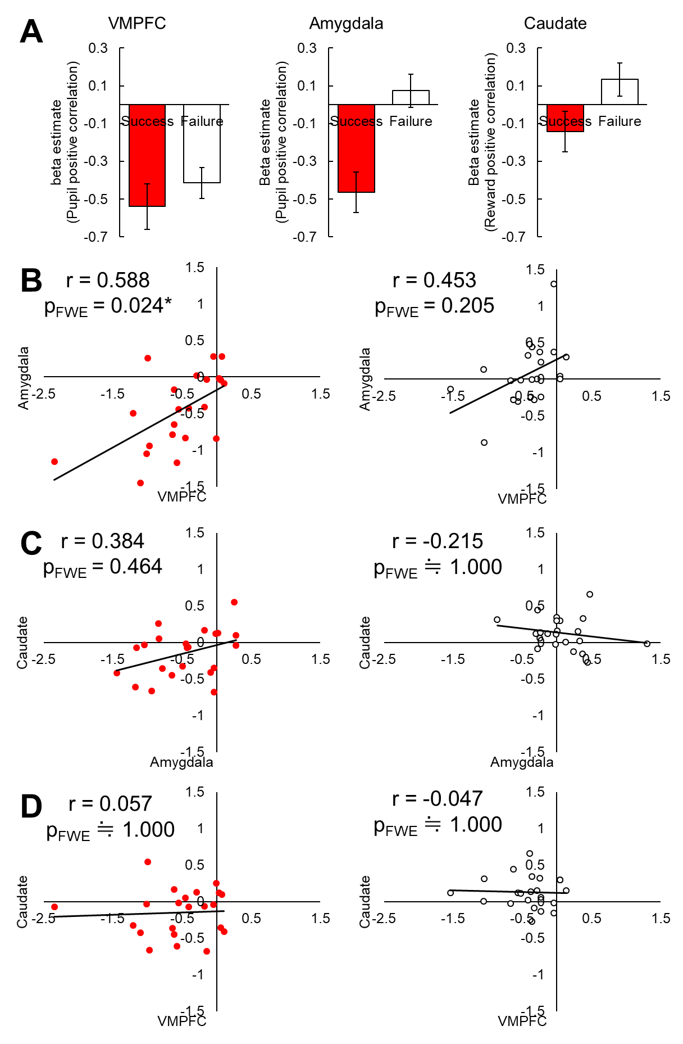**Supplemental Figure 1**

**Figure S1, Beta estimates and those correlations across VMPFC, amygdala, and caudate nucleus.**

A) Beta estimates of each seed in success and failure trials. B, C, and D) Correlations of each beta estimates in success (left, red points) and failure (right, white points) trials. Only VMPFC and amygdala correlation in success trials showed a significant positive relationship (r = 0.588, pFWE = 0.024)

**Supplemental Figure 2**

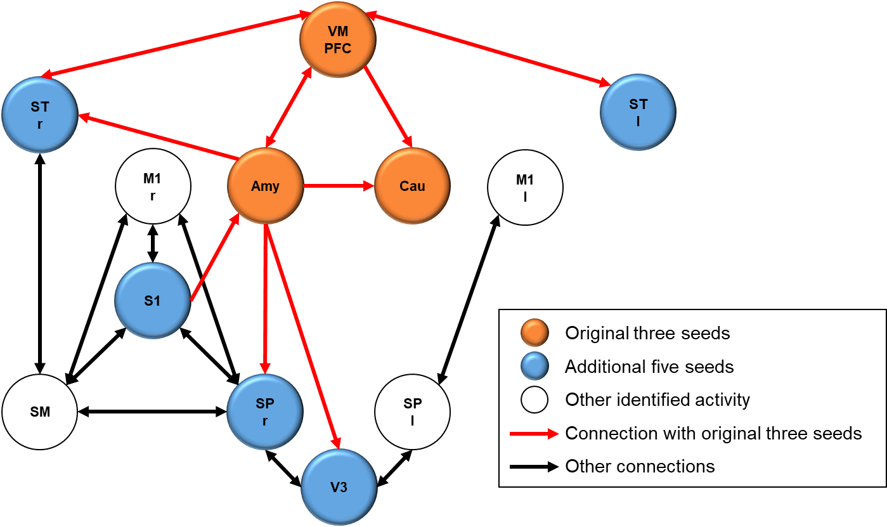

**Figure S2. Anatomical connections among reported regions in the current results.**All seed regions were selected based on Table 1 in the main manuscript in addition to arousal-related amygdala and reward-related caudate nucleus seeds. Connection arrows were described based on known anatomical connections.Abbreviations; Amy: amygdala, Cau: caudate nucleus, M1: precentral gyrus, S1: postcentral gyrus, SM: supra marginal, SP: superior parietal cortex, ST: superior temporal cortex, V3: superior occipital region, VMPFC: ventromedial prefrontal cortex

**Supplemental Figure 3**

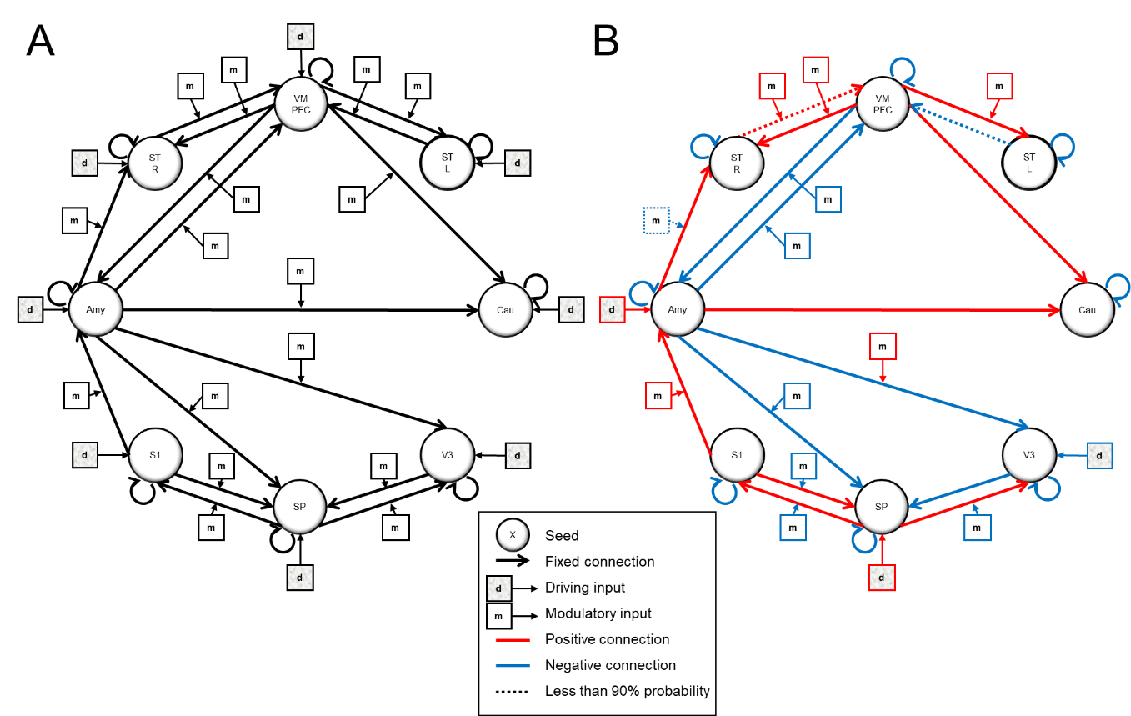

**Figure S3. Result of dynamic causal modeling with 8 seed regions.**

A) Hypothesized full model and B) optimized model by post-hoc Bayesian selection. The optimized model was consistent with the original three seed model supporting suppressive modulation of the amygdala from VMPFC.

**Supplemental Methods**

**Additional DCM with eight seed regions**

In the current analyses, the ventromedial prefrontal cortex (VMPFC) was chosen as the seed given the hypothesis that it is potentially modulating the arousal-related amygdala and reward-related caudate activity. However, we also identified other regions in temporal, parietal and occipital lobes, which were negatively correlated with mean pupil amplitude (as was VMPFC; see Table 1). These regions could potentially contribute to the control of physiological arousal in addition to VMPFC. We conducted additional analysis with these regions added as seeds in the DCM and evaluated the stability of our findings compared to the original three seed model.

First, prior to the analysis, we checked anatomical connections across all observed clusters to confirm whether each seed is directly connected with amygdala, caudate or VMPFC, based primarily on anatomical tracing studies in nonhuman primates and rodents (Figure S2). This process is important because, for DCM, it is strongly recommended to use a prior based on actual anatomical connection (Stephan et al., 2010, 2009; Sokolov et al., 2019). The superior occipital region (V3), which corresponds to V3 area and Brodmann area (BA) 19, receives projections from amygdala (Amaral et al., 2003; Amaral and Price 1984; Freese and Amaral, 2005; Iwai and Yukie, 1987). Although visual information is sent from occipital lobe via ventral and dorsal visual pathways, direct projections from the occipital lobe to amygdala have not been reported in non-human primates (Aggleton et al., 1980; Iwai and Yukie, 1987; Stefanacci and Amaral, 2000), although a projection from occipitotemporal junction region to amygdala has been reported in rodents (McDonald and Mascagni, 1996). One human study with diffusion tensor imaging also reported an anatomical connection between middle fusiform gyrus and amygdala, but the direction of the connectivity is unknown (Smith et al., 2009).The postcentral gyrus (S1), corresponding to primary somatosensory area or BA1,2,3 sends projections to amygdala (McDonald, 1997; Romanski et al., 1993), The superior temporal cortex (STr, STl), corresponding to BA 22, and TC area, receives projections from amygdala ipsilaterally (Amaral and Price, 1984; Yukie, 2002). STr and STl also have bidirectional anatomical connections with VMPFC (Yeterian et al., 2012). The superior parietal cortex (SPr, SPl), corresponding to BA7, receives ipsilateral projections from amygdala (Amaral and Price, 1984) but there is no evidence that amygdala receives direct projections from parietal cortex (Aggleton et al., 1980; Stefanacci and Amaral, 2000). Other regions including supra marginal (SM), precentral gyrus (M1r, M1l: corresponding to primary motor area) are not directly connected with the three original seeds (Burks et al., 2016; Yeterian et al., 2012).

Based on these anatomical knowledge, we selected right superior occipital gyrus (V3), right postcentral gyrus (S1), bilateral superior temporal cortex (STr and STl), and right superior parietal cortex (SP) as seeds in addition to amygdala, caudate and VMPFC for the additional DCM analysis. We did not include all 10 seeds because the other four regions are not directly connected with the original three regions. We tested the DCM with eight seeds as shown in Figure S3A. We did not impose any constraints on driving nor modulatory inputs as there are several possible variations of starting points and modulations in the network as well as original three seed full model. The eight seed full model was optimized by post-hoc Bayesian model selection.

**Supplemental Results**

**Results of eight seed region analysis**

Post-hoc model optimization from the full model (Figure S3A) found one winning model (Figure S3B) from 240 possible combinations (28 driving inputs, 216 modulatory inputs and 216 fixed connection). This model has the highest posterior probability (37.2%) and the ratio of the best and the second best model probability (Penny et al., 2004) was 37.2 / 0.98 = 3.796. This optimized model results were consistent with the original three seed results. First, the amygdala was negatively modulated by VMPFC in success trials. The only region which suppressed the amygdala activation was VMPFC in this model. Second, the modulatory connections from amygdala to caudate and from VMPFC to caudate were deleted by the optimization, as in the original three seed model. Third, the fixed connections both from amygdala to caudate and from VMPFC to caudate showed a positive value. Fourth, the driving input originated from amygdala and not from VMPFC nor caudate.

On the other hand, an inconsistency with the original three seed results was that the fixed connections from amygdala to VMPFC and from VMPFC to amygdala were classified as having negative values. We also found additional functional modulations with the new seeds. For example, we identified that the right superior temporal cortex (STr) received positive input from the amygdala and sent positive output to the VMPFC. This STr to VMPFC functional connection was positively modulated in success trials. Parieto-Occipital network including the superior occipital gyrus (V3), postcentral gyrus (S1) and superior parietal cortex (SP) which connected with the amygdala also dynamically changed in the success trials compared with all trials.

In sum, this additional analysis with eight seeds was consistent with the original three seeds analysis. In particular, the suppressive relationship from VMPFC to amygdala in the success trials was confirmed. Additionally, we identified the contribution of right superior temporal cortex by this model. It is possible that the positive network modulation from amygdala to VMPFC identified by the original three seed model was implemented via the superior temporal cortex modulation.

**Supplemental References**

Aggleton, J.P., Burton, M.J., Passingham, R.E., 1980. Cortical and subcortical afferents to the amygdala of the rhesus monkey (Macaca mulatta). Brain Res 190, 347-368.

Amaral, D.G., Behniea, H., Kelly, J.L., 2003. Topographic organization of projections from the amygdala to the visual cortex in the macaque monkey. Neuroscience 118, 1099-1120.

Amaral, D.G., Price, J.L., 1984. Amygdalo-cortical projections in the monkey (Macaca fascicularis). J Comp Neurol 230, 465-496.

Burks, J.D., Boettcher, L.B., Conner, A.K., Glenn, C.A., Bonney, P.A., Baker, C.M., Briggs, R.G., Pittman, N.A., O'Donoghue, D.L., Wu, D.H., Sughrue, M.E., 2017. White matter connections of the inferior parietal lobule: A study of surgical anatomy. Brain Behav 7, e00640.

Freese, J.L., Amaral, D.G., 2005. The organization of projections from the amygdala to visual cortical areas TE and V1 in the macaque monkey. J Comp Neurol 486, 295-317.

Iwai, E., Yukie, M., 1987. Amygdalofugal and amygdalopetal connections with modality-specific visual cortical areas in macaques (Macaca fuscata, M. mulatta, and M. fascicularis). J Comp Neurol 261, 362-387.

McDonald, A.J., 1998. Cortical pathways to the mammalian amygdala. Prog Neurobiol 55, 257-332.

Penny, W.D., Stephan, K.E., Mechelli, A., Friston, K.J., 2004. Modelling functional integration: a comparison of structural equation and dynamic causal models. Neuroimage 23 Suppl 1, S264-274.

Romanski, L.M., Clugnet, M.C., Bordi, F., LeDoux, J.E., 1993. Somatosensory and auditory convergence in the lateral nucleus of the amygdala. Behav Neurosci 107, 444-450.

Smith, C.D., Lori, N.F., Akbudak, E., Sorar, E., Gultepe, E., Shimony, J.S., McKinstry, R.C., Conturo, T.E., 2009. MRI diffusion tensor tracking of a new amygdalo-fusiform and hippocampo-fusiform pathway system in humans. J Magn Reson Imaging 29, 1248-1261.

Sokolov, A.A., Zeidman, P., Erb, M., Ryvlin, P., Pavlova, M.A., Friston, K.J., 2019. Linking structural and effective brain connectivity: structurally informed Parametric Empirical Bayes (si-PEB). Brain Struct Funct 224, 205-217.

Stefanacci, L., Amaral, D.G., 2000. Topographic organization of cortical inputs to the lateral nucleus of the macaque monkey amygdala: a retrograde tracing study. J Comp Neurol 421, 52-79.

Stephan, K.E., Penny, W.D., Moran, R.J., den Ouden, H.E., Daunizeau, J., Friston, K.J., 2010. Ten simple rules for dynamic causal modeling. Neuroimage 49, 3099-3109.

Stephan, K.E., Tittgemeyer, M., Knosche, T.R., Moran, R.J., Friston, K.J., 2009. Tractography-based priors for dynamic causal models. Neuroimage 47, 1628-1638.

Yeterian, E.H., Pandya, D.N., Tomaiuolo, F., Petrides, M., 2012. The cortical connectivity of the prefrontal cortex in the monkey brain. Cortex 48, 58-81.

Yukie, M., 2002. Connections between the amygdala and auditory cortical areas in the macaque monkey. Neurosci Res 42, 219-229.